Statistical precision estimation in charged particle EDM search in storage rings
A. Aksentev^{#1,2}, Y. Senichev¹
¹ IKP, Forschungszentrum Jülich, Germany
² National Research Nuclear University «MEPhI», Russia

Abstract
Currently, the “Jülich Electric Dipole moment Investigations” (JEDI) collaboration together with the present EDM experiments at the COSY ring is developing the conceptual design of a ring specifically for the search for the deuteron electrical dipole moment (dEDM). One of the main problems in the EDM study is the spin precession in the vertical plane caused by the non-ideal positioning of the accelerator elements through the magnetic dipole moment (MDM). The idea of how to separate the EDM from MDM is based on measuring the spin tune in different processes and comparing the results. The high precision of the spin tune measurement is achieved by collecting data during one year. The JEDI collaboration aims detecting the dEDM at a level better than <10⁻²⁹, for which one requires a precision in the frequency estimate ~10⁻⁹. An estimate's statistical precision is conditional on the following factors: the total measurement time, determining the independent variable spread; measurement error; temporal modulation and spacing of sample points.
In this paper we analyze the interplay between these factors, and estimate the best achievable precision under the given conditions.

introduction
One of the essential problems of modern physics is the baryon asymmetry of the Universe that represents the prevalence of matter over antimatter [1]. In addition, cosmic detectors, whose purpose is to search for antimatter, PAMELA and AMS haven’t found any significant amount of it in the Universe yet [2]. The development of the new idea that claims one of the reasons for the baryon asymmetry is the breaking of CP invariance, has begun soon after its discovery. A. Sakharov established three necessary conditions for baryogenesis (initial creation of baryons) in 1967 [3]:
• Baryon number violation;
• C-symmetry and CP-symmetry violation;
• Interactions out of thermal equilibrium.
Many theories beyond the SM have been proposed and all of them of so-called "New Physics" are able to remove the difficulties that one meets in the Standard Model, but
their experimental confirmation has yet to be found. One of the possible arguments for the breaking of CP-invariance is the existence of non-vanishing electric dipole moments (EDM) of elementary particles.
__________________
#a.aksentev@fz-juelich.de

Currently, the “Jülich Electric Dipole Moment Investigation” (JEDI) collaboration works in two directions: first on the existing accelerator COSY the precursor experiment is carried out to prove the feasibility of EDM measurement using the storage ring [4,5,6], and secondly the conceptual design of the ring specifically for search of the deuteron electrical dipole moment (dEDM) is being developed [7]. At present the RF flipper for installation on COSY ring is progressing successfully. Besides, we have already obtained very important experimental results with precise measurements of the spin precession frequency [4,5] which will allow calibrating the particle energy using the clock-wise and counter clock-wise procedure, and we have reached the longest spin coherence time ~1000 sec in horizontal plane [6].
basic principle of EDM search in ring
At present there are two options for a future dEDM ring based on the frozen (FS) and quasi-frozen spin (QFS) concepts [7]. The idea of the FS concept has been suggested by BNL [8], and it is based on the elements with incorporated electric and magnetic fields in one element, when the spin of the reference particle is always oriented along the momentum.
Studying the FS structure, we have paid attention to the fact that the frozen spin condition is performed only for the reference particle, and the spin vector of all other particles oscillates relative to the frozen direction. But if so, it might not be worth it to strictly fulfill the frozen spin condition even for the reference particle. If the spin oscillates in the horizontal plane with respect to the frozen spin direction with an amplitude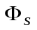, then the EDM growth decreases proportionally to the factor 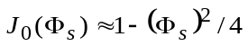. Taking into account that the deuteron’s anomalous magnetic moment  has a small value and the fact that the spin oscillates around the momentum direction within half the value of the advanced spin phase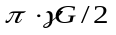 in the magnetic arc, each time returning [where?] in the elements with the electrical field on the straight sections, it is obvious that the effective contribution to the expected EDM effect is reduced only by a few percent. This allows us to proceed to the concept of the quasi-frozen spin (QFS) [9], where the spin is not frozen with respect to the momentum vector, but continually oscillates around momentum with a small amplitude of a few degrees.
In case of the quasi-frozen spin concept, we have two lattice options. In the first option, the electric and magnetic fields are fully spatially separated in the elements of the arcs and the straight sections.
In the second option of the QFS lattice we introduced a magnetic field of small value ~100 mT, compensating the Lorentz force of the electric field in the straight section (see fig.1).
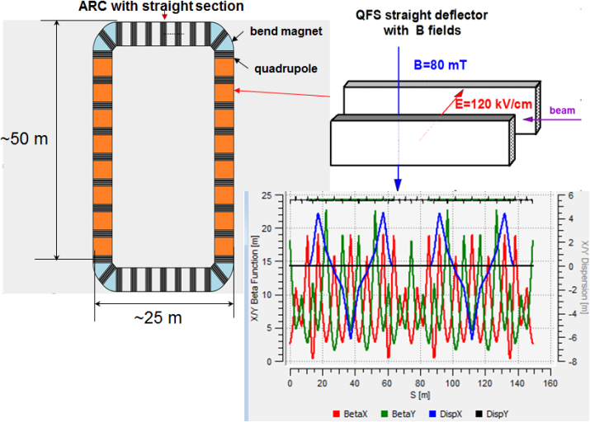
Figure 1: QFS lattice with TWISS functions.
In both cases the QFS lattice has the conventional magnetic arcs with zero dispersion in the straight sections in the middle for the installation of the polarimeter, the beam extraction and injection systems, and the RF cavity.
The simplicity of the QFS concept makes it possible to realize this lattice in the existing COSY ring to search for the dEDM.
Systematic errors
Generally, measurement error can be separated into two components: random error and systematic error. Systematic error is the error component which remains constant in repeated measurements and is caused by imperfections of the physical facility. In the EDM ring, systematic error arises due to the misalignment of the electric and magnetic elements in the ring and generates a “fake” EDM signal. The misalignments are caused by installation errors, due to the limited accuracy of geodetic instruments. As is known, a bending magnet (or the electric deflector) can be rotated in three planes. We consider only the rotation around the longitudinal and transverse axes, because the rotation around the vertical axis does not introduce a systematic error.
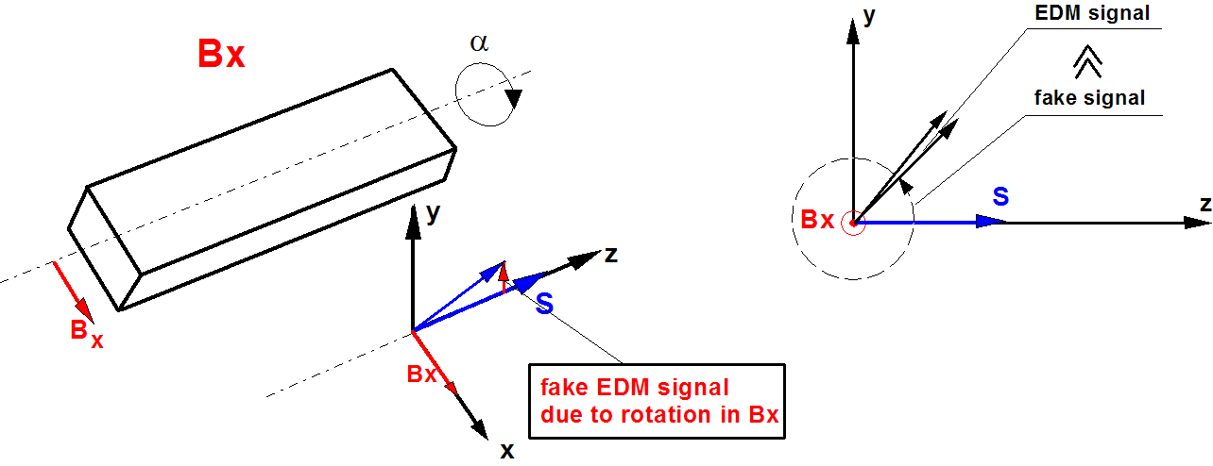
Figure 2: Magnet rotating relative to longitudinal axis.
First, let us consider the case of the magnet rotated relative to the longitudinal axis (see Fig.2). Due to such rotation, a horizontal component of the magnetic field 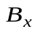 arises and causes the spin rotation 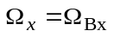 in the same plane where we expect the EDM rotation. To illustrate, let us write the solution of the T-BMT equation with initial condition 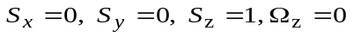and 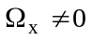 in the simplest form:
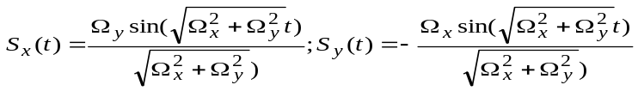.(1)
Taking the above into account, we can present the components: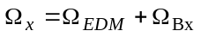and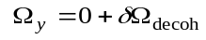, where 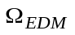is the frequency of spin rotation due to the presence of an EDM, is the horizontal component induced by the magnet rotation (misalignment), and 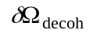 is the spin tune decoherence in the horizontal plane. Since the decoherence is allowed to reach an rms value of 1 rad for spin coherence time t_{SCT}>1000 sec, that is the rms value of 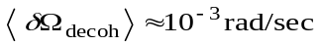.
The magnets are supposed to be installed at the technically realized accuracy of 10μm, which corresponds to the rotation angle of the magnet around the axis of about 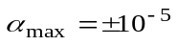rad. Using COSY Infinity [10] and MODE [11], we have calculated the MDM spin rotation due to B_{x}, which is 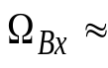3 rad/sec. At the same time, at the presumable EDM value of 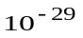e·cm, the EDM rotation should be 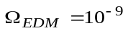rad/sec, that is 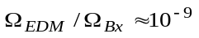, and expression (1) can be simplified without loss of measurement accuracy of the possible EDM signal at the level of 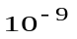:
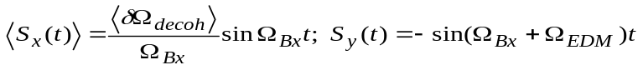. (2)
We can see from the first equation of (2) that the spin decoherence in the horizontal plane is not growing and is stabilized at the level of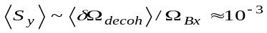. This is a significant positive feature. But to be fair, we should understand that, since 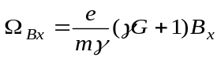, we will now get due to 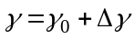 the spin frequency decoherence 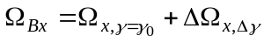in the vertical plane around horizontal axis, which one we can minimize by the same methods (sextupoles, RF) as in the horizontal plane. In addition, we are really deprived of the ability to measure the accumulated EDM signal by the growth of the vertical component of spin suggested in [8], since the spin rotation due to the magnet errors is much faster than due to a possibly existing EDM 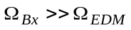. That is 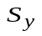reaches a maximum in a very short time while the EDM signal does not have time to accumulate.
Therefore, the only solution is to measure the total frequency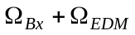, but in order to split out the EDM signal from the sum signal, we need an additional condition. Such a condition is to measure the total spin frequency in the experiment with the counter clock-wise (CCW) direction of the beam 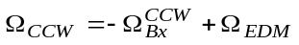 and compare it with the clock-wise (CW) measurement 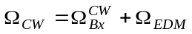. At the same time, one must understand that the measurement accuracy of the 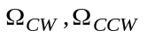 frequencies determines the precision of the EDM measurement.
Let us assume that we can measure them with the accuracy 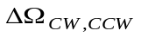=10⁻⁹ (we will discuss the requirements for than kind of statistical precision in detail in the next paragraph). Then we will be able to determine the EDM signal by the simple addition at the level of ~10⁻²⁹e·cm. Additional orders of magnitude could be obtained by adjusting sampling to the signal and using a faster detector [13]. That way, we would have a greater number of useful events (those in the interval when the polarization asymmetry changes faster) with smaller statistical errors. Thus, such an approach looks promising.
However, we need to be sure that when the sign of the driven magnetic field 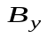 for the CW-CCW is changed, the magnetic field component is restored with the required relative precision of not lower than 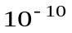. Therefore, we suggest calibrating the field in the magnets using the relation between the beam energy and the spin precession frequency in the horizontal plane, that is, determined by the vertical component . Since the magnet orientation remains unchanged, and the magnets are fed from the same power supply, the calibration of will restore the component with the same relative accuracy , which applies to the difference 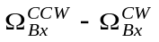as well. Besides, we should mention that the calibration in the horizontal plane does not involve the EDM signal. Thus, this calibration will not decrease the accuracy of the EDM measurement, and it will be finally defined by accuracy of 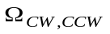measurement.
We shall not discuss here the other systematic errors arising from the rotation of the magnet with respect to the longitudinal axis, because it does not mix the EDM and MDM signals and is quite well discussed in [12].
statistical sensitivity of EDM measurement
So,……
Conclusion
In the paper, we analyzed the frozen and quasi-frozen spin structures, taking into account the effect of spin decoherence and systematic errors. It has been shown how you can measure the EDM in an imperfect ring using achieved the experimental results of spin tune measurement and the beam polarization lifetime of 1000 sec. In the proposed conception we use: the calibration energy in horizontal plane and measurement in vertical plane, the invariability of ratio 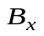to after change of polarity in all elements. These estimates show that the lower limit of detection of presumably existing EDM can be as low as ~10⁻²⁹e·cm.
References
[1] Canetti L., Drewes M., Shaposhnikov M. (2012). "Matter and Antimatter in the Universe", New Journal of Physics, 14, 095012.
[2] Aguilar M., Alberti G., Alpat B. et al., (2013) "First Result from the Alpha Magnetic Spectrometer on the International Space Station: Precision Measurement of the Positron Fraction in Primary Cosmic Rays of 0.5 - 350 GeV", Phys. Rev. Lett., 110, 141102.
[3] Sakharov A. (1967). "Violation of CP Invariance, C Asymmetry, and Baryon Asymmetry of the Universe", Letters to Jounal of Experimental and Theoretical Physics, 5, 24- 26.
[4] Z. Bagdasarian et al., Measuring the polarization of a rapidly precessing deuteron beam, Phys. Rev. ST Accel. Beams 17, 052803 (2014)
[5] D. Eversmann et al., New method for a continuous determination of the spin tune in storage rings and implications for precision experiments, Phys. Rev. Lett. 115, 094801 (2015)
[6] G. Guidoboni, et al., How to reach a thousand-second in-plane polarization lifetime with 0.97-GeV/c deuterons in a storage ring, Phys. Rev. Lett. 117, 054801, (2016)
[7] Y.Senichev et al., Investigating of lattice for deuteron EDM ring, Proceedings of ICAP 2015, Shanghai, China, pp. 17-19
[8] D. Anastassopoulos et al., “AGS Proposal: Search for a permanent electric dipole moment of the deuteron nucleus at the 10−29 e · cm level”, BNL, 2008.
[9] Yu.Senichev et al., Quasi-frozen Spin Method for EDM Deuteron Search, Proceedings of IPAC2015, Richmond, VA, USA
[10] M. Berz, “Computational Aspects of Design and Simulation: COSY INFINITY”, NIM A298, (1990).
[11] Ivanov A. et al., (2014), "Matrix Integration of ODEs for Spin-orbit Dynamics Simulation", Proc. of IPAC2014, Dresden, Germany, 400-402.
[12] Yu.Senichev, et al., Systematic Errors Investigation in Frozen and Quasi-Frozen Spin Lattices of Deuteron EDM Ring, Proceedings of IPAC2016, Busan, Korea
[13] I.Keshelashvili, Towards JEDI Polarimetry, XVIth International Workshop in Polarized Sources, Targets, and Polarimetry, PSTP2015, Bochum, Germany

